Parkhill Secondary School

Digital Learning Strategy
Digital Learning Strategy – Parkhill Secondary School

Our Vision
At Parkhill Secondary School our vision is for all of our learners, staff and families to access digital technology. This will allow everyone to further their learning and access a wider range of opportunities whilst raising attainment and ambition within our growing digital world.

Our Aim
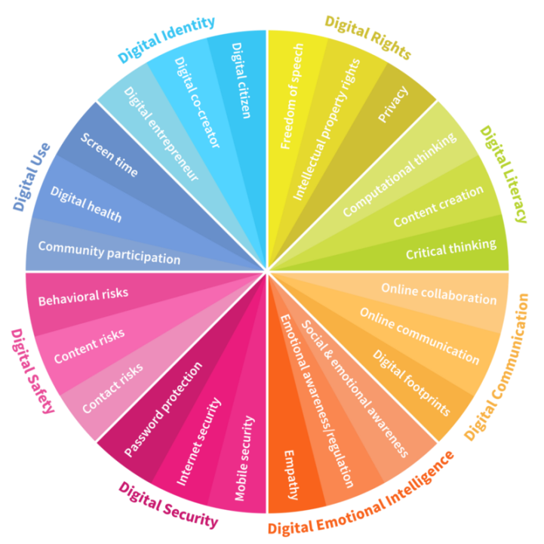
The aim of this strategy is to implement the use of digital technology in order to create the conditions to unlock the full potential of digital technology in our school and community.

The Digital Intelligence diagram from the World Economic Forum
Our Digital Learners
- We will ensure that our learners have quality learning experiences in which digital technologies can help support and enhance the learning taking place
- We will purchase and provide support in using new technology that reflects our ever changing and adapting digital society
- Our learners will have access to online tools and resources that can address barriers to learning and help support their learning needs
- Their digital learning experiences will help provide them with the tools and knowledge to use technology appropriately both at school and at home
- Our learners will understand the risks associated with using technology and working online and will receive support in identifying and managing these
- Our learners will be provided with the skills to critically evaluate materials they find online and understand how to safely and legally use this content
- Our learners will have access to tools that will allow them to find, evaluate, utilise, share and create content
- Our learners will be educated about online etiquette, identity and reputation to ensure they build positive relationships with their peers online

Our Staff
- Our Digital Learning Strategy will be shared and supported by the Senior Leadership Team, Teaching Staff, Support for Learning Workers and all other stakeholders
- The member of staff who is the named Digital Leader of Learning will continue to meet with and share updated information on our city’s digital landscape
- Modelled lessons and specialist visitors will help demonstrate the value of Digital Learning and allow teachers to share examples of good practice
- Time allocated for digital meetings and evaluating digital experiences will be allocated into our school’s working time agreement
- In house training will be provided for teachers and all staff from the Digital Leader of Learning and from staff wishing to share good practice
- All PRDS will include developments in aspects of Digital Learning
- We will continue to encourage collaboration and innovativeness between all staff in order to incorporate personalisation and choice and indeed using technology to remove barriers for learning
- All staff will work together to evaluate the impact of digital technologies on learning and report back to the Senior Leadership Team and the Digital Leader of Learning to allow evidence to be collated and shared
- On-going support will be put in place through the Digital Leader of Learning to support staff members looking to try specific hardware, software or other digital approaches

Parents, Carers and Families
- Our Digital Learning Strategy will be shared with parents, carers and families
- We will continue to work with parents, carers and families to ensure they are made aware of the technologies we are using to support teaching and learning
- We will introduce the use of digital sharing of pupils work to allow parents and carers to see pupil progression in a digital form
- We will continue to provide information for parents, carers and families on Cyber Resilience, Internet Safety and Digital Literacy
- We will continue to offer and arrange support for our parents, carers and families to help them support their child with digital learning and in coping with the demands of an evolving digital world
- We will continue to liaise with the Parent Council group to discuss our Digital Learning Strategy and they will play a vital role in evaluating its progress
- We will continue to incorporate many digital family learning experiences, continually seeking new ideas and ways to improve communication and collaboration

Measuring Impact
We will measure our starting point by......
- Learner conversations regarding teaching and learning experiences, purchase of new technology and in house clubs and specialist visitors
- Staff consultation through PRDs
- Parental consultation
- Attainment and Achievement figures

We will measure the impact of our Digital Strategy by......
- Pupil Voice
- Parental consultation
- Staff consultation
- Partnership working consultation with agencies
- Attainment and Achievement figures
- The increase and recruitment of Digital Leaders and Digital Leadership from pupils and staff
- Digital Learning in house training and modelled lessons from Digital Leaders both pupils and staff
- Progression forward for the Digital Schools Awards

Managing Technology
- We will work closely with GCC and XMA to plan our roll out in line with local authority requirements
- A dedicated member of staff (Digital Leader of Learning) will be in charge of the digital resources and any issues should be reported to the correct team
- Devices and data will be stored securely as per the council requirements
- All staff and pupils trained annually on data security processes
- Yearly parental reminder of GCC policy on data security

Financial Sustainability
- Research costs for covers, screen protectors, storage, charging solutions, keyboards and other accessories
- Savings made through reduced reliance on textbooks, paper, stationery and other consumables
- On-going costs will be monitored and evaluated regularly

